**ASSIGNMENT 1**

**AIM:-**

Design and Develop SQL DDL statements which demonstrate the use of SQL objects such as Table, View , Index, Sequence, Synonym.

**OBJECTIVE:-**

To implement DDL operations and table, sequence, index, synonym, view.

**OUTPUT:-**

**Create table:**

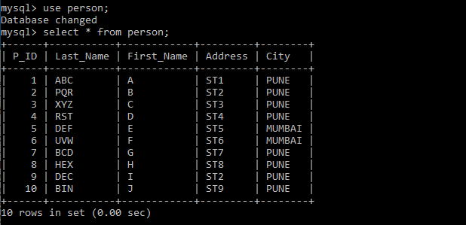

**VIEW**

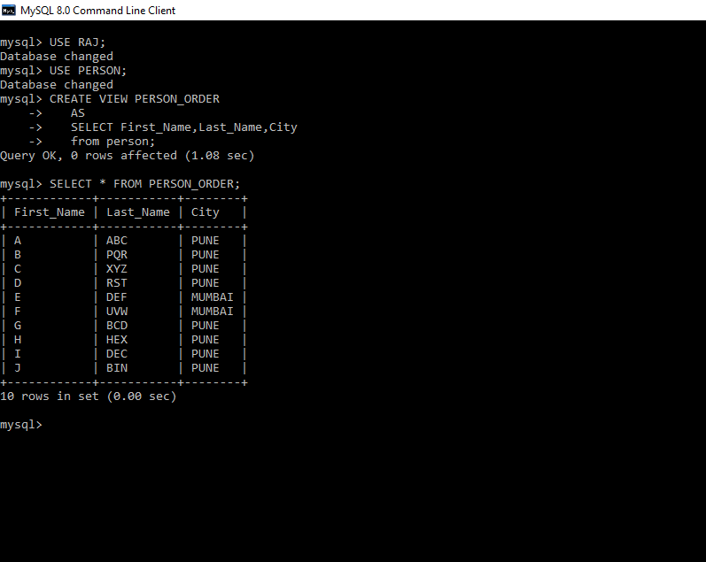

**DROP VIEW**



**INDEX**

